General Observations

- Generally, the site is too dark. We need to find ways of lightening things up. I still like the dark-mode theme, but somehow it needs more contrast. Some general suggestions to try:
  - Use tiles that have light backgrounds / colored backgrounds
  - Establish a color standard for call-to-action buttons and use those instead of dark background buttons
  - Perhaps brighten the background a bit
  - Put text on tiles that can be light and dark
  - Create animations that have more color to them (i.e. the animations under the Indsutry section
  - Alternate light and dark sections rather than every section being dark
  - (All of these are just ideas. Overall I love the take.)
- Please increase the font size for everything except headings. Every text that should be readable should be 12px, minimum. Maybe even 14. Then only supporting text or labels should be smaller than that. Subheadings “COMPLIANCE EXPERTISE” and the like should be bold like they are but simply bigger.

Hero
- Can we make the Menuj below the Hero Title be sticky, or somehow sticky at the top? Or perhaps move the menu to the top and keep it sticky. Want the ability to navigate from anypoint on the page.
- Can you make the “Sidechain Defense: Active” label bigger so we can see the pulse a bit more? This is awesome, and makes it look like something is actively in place for the viewer. Very cool.
- For the background, instead of the moving constellation pattern, could you try and design a gradient hexagon? Like this:

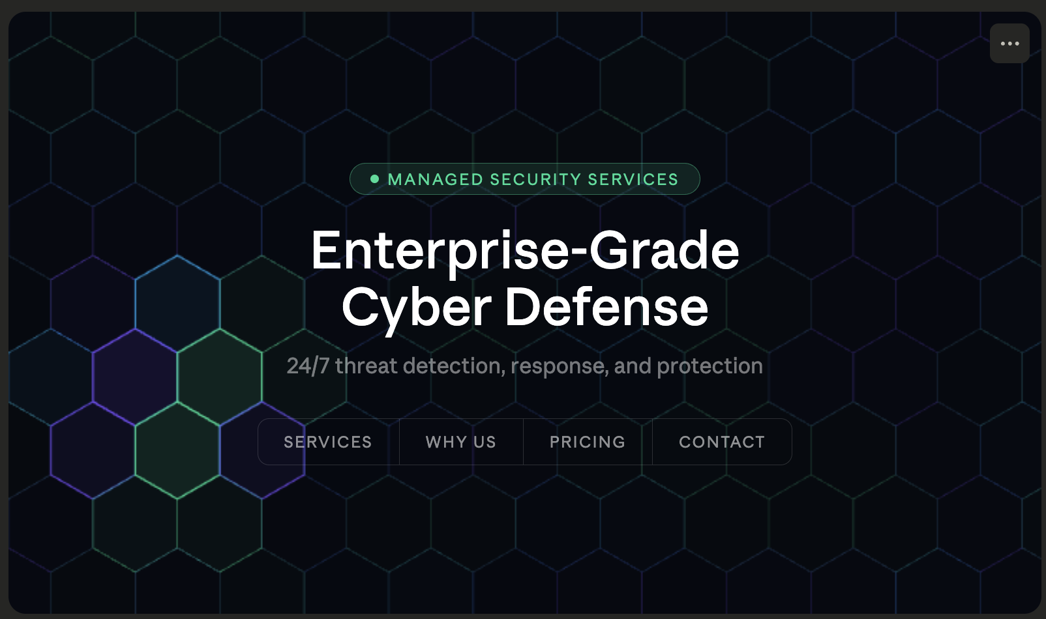
Kind of like the original gradient background you had when we designed it as a Solana page, except instead of the stacked nodes, we’re using hexagons? The hex is a very common cybersecurity symbol and will be more recognizable by viewers.

THE REALITY
This section is just awesome. The animations are very cool. I think we need some more text under it. But I’m not sure what to put here. Can you have Claude build out some text for this? Something like “When your cybersecurity posture is regulated, there’s a lot riding on getting it right. Eliminate the risk, turn to cybersecurity experts from Sidechain to pass audits the first time, every time. Sidechain helps ensure that security is working for you, protecting your data, your business, and your revenue.” these kinds of things.

THREAT ASSESSMENT
For the three tiles, can you eliminate the animated buttons - they are cool, but just a bit much. The buttons should be a color. And perhaps you could animate the button on hover or something.

24/7 MANAGED DEFENSE
Really great animation. Let’s build on this.
Have the five clickable icons around the shield be:
- Threat Monitoring (was SIEM)
- Data Protection (was BACKUP)
  - Popup tile header should be “Data Protection & Incident Response”
  - Text on the panel should read “Protect your data through secure backup, restore validation, incident response planning, and a tested playbook for breach response. No panicking necessary.”
- EDR - keep it, it’s perfect
- Email Security (was EMAIL)
- Vulnerability Assessment (was PATCH)
  - Header should be “Vulnerability Assessment & Patch Management”
  - Tile text is fine.

Even though we are getting away from the one-word labels around the shield, the reason for this is that things like ‘data protection’ and ‘vulnerability assessment’ are industry-known terms, instantly recognizable. So we want to capture that awareness.

OUR DIFFERENTIATOR
So This part looks great. I’m a little torn on the globe animation in the background. I’m torn because I think it’s awesome and I really like it, but I’m struggling because it doesn’t seem related to data security at all. So I wonder if it will cause confusion?

Also this is a section where if we had a bigger label for OUR DIFFERENTIATOR it would be easier for the viewer to recognize that this is a big deal. There aren’t MSSP’s that know how to do this like we do. So I really want to play this up.

COMPLIANCE EXPERTISE
This section is nearly perfect, very cool, hits great. This is, however, a section that I think needs more color or to kind of brighten things up. Perhaps color the industry menu bar or something like that. And in general if the text were a little bigger it would go a long way.

The other feedback here is the stats are a little made up - understand these are just starting points. But 95% audit readiness, for example, doesn’t really connect. See the end of this doc for statistics you could use. Or make them 100% in some cases, like Payment Protection / retail. That is 97% right now, but that’s not acceptable. You get the idea.

PRICING
Add a third box, to the left of the RECOMMENDED box, that is $1,500 that is a comprehensive cybersecurity assessment for organixations up to 10 employees. Here’s the copy for that pricing box:
Name: Cyber Security Health Check
Tagline: Your organization's 60-point security inspection — delivered as a clear, actionable report.
Price: $1,500 — One Time
Includes:
- Email security review — SPF, DKIM, DMARC configuration and spoofing exposure analysis
- External vulnerability scan — identification of exposed ports, services, and known CVEs on internet-facing systems
- Website security assessment — SSL/TLS configuration, web application headers, and common exposure checks
- Dark web credential scan — check whether employee credentials from your domain are circulating in breach databases
- Endpoint posture review — assessment of device management, patching status, and AV/EDR coverage gaps
- Data risk assessment — identification of sensitive data exposure risks including unencrypted storage and access control gaps
- Cloud configuration review — key misconfiguration checks across cloud services in use (AWS, Azure, or Google Cloud)
- Phishing susceptibility snapshot — review of email gateway configuration and employee security awareness posture
Deliverable: A written report with findings, risk ratings, and a prioritized remediation checklist — ready to share with leadership or your board.
CTA: Schedule a Health Check →
Small print: Most clients complete the Health Check in under two weeks with minimal disruption. Results are often used as the foundation for an ongoing managed security program.

STATS TO USE
Hard numbers you already own:
- 250+ satisfied customers (already on the site)
- 10+ years of data security expertise (already on the site)
- 100% satisfaction guarantee (already on the site)
- The specific vendors you're certified on — Thales, Entrust, Utimaco, Fortanix, AWS, Azure, GCP — that's 7 named platforms, which is actually a meaningful number
Stats that are real if you can verify them internally:
- Number of encryption implementations completed (100+)
- Number of HIPAA assessments delivered (40+)
- Number of compliance audits passed (across your client base) (100’s)
- Average client tenure / retention rate — if it's high, that's powerful (7 years)
Industry stats you can borrow with attribution — this is a common and legitimate approach. Cite the source, use the stat:
- "74% of breaches involve the human element" (Verizon DBIR)
- "The average cost of a healthcare data breach is $10.9M" (IBM Cost of a Data Breach Report)
- "60% of SMBs that suffer a cyberattack go out of business within 6 months" (widely cited)
These work really well in a "why this matters" context and make the compliance section feel authoritative rather than self-congratulatory.
My honest recommendation to the designer: replace the percentage progress bars entirely with a clean 4-stat grid using only numbers you can stand behind — something like:
Stat | Label
250+ | Customers Protected
10+ Years | Data Security Expertise
7 | Certified Encryption Platforms
4 | Major Compliance Frameworks

